|  |  |  |
| --- | --- | --- |
| **MEDIA RELEASE** | Contact: Peter Jarvis | |
| Storm Interface | |
| Phone: +44 (0)1895 456200 | |
| Email: sales@storm-interface.com | |
| **London, England. September 2016** | Web: [www.storm-interface.com](http://www.storm-interface.com) | |
| **Storm Interface and ADI Global Distribution announce a new initiative** | |

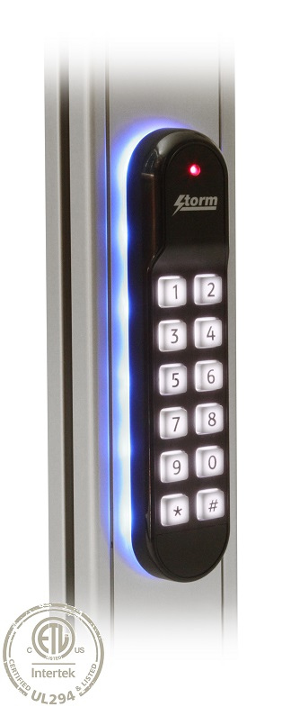

**Seen for the first time at the Security Show in Essen Germany, the new Storm-AXS S60 Keypad-reader** will be featured on the Storm-Interface stand. This visually striking access control keypad has been developed for use in exposed outdoor locations. Locations where typically there is limited space available for installation of a keypad-reader. **Restricted installation space is often a problem in buildings with glass, or polished stone exterior walls where installation into the door frame is the only practical option.** These installations require a keypad-reader with a narrow, vertically oriented format.

The challenge met by Storm is to achieve this narrow format without compromising mandated accessibility requirements or compliance with the new UL294 standard. **The keypads also feature HID iCLASS contactless reader technology providing dual technology authentication and elevated levels of security.**

**As the latest addition to the Storm-AXS range of weather resistant and toughened access control devices, the S60 will also feature in a new initiative announced by Storm and their distribution partner ADI Global Distribution.** During and after the launch of these new products at the Essen show, ADI Global Distribution will be working with Storm to ensure these products are visible and available to ADI Global Distribution customers in the UK, Germany and throughout the emerging European territories. This initiative will include social media and targeted email campaigns reinforced by a poster campaign in ADI Global Distribution sales centres.

ADI Global Distribution’s Joseph Davies explained, “Increasing demand for frame mounted keypad-readers is emerging as expensive glass and other high-tech finishes are specified by architects and their clients. ADI Global Distribution are committed to meeting the specific requirements of architects and other system designers”.

****For more information about the S60, please visit [www.storm-interface.com](http://www.storm-interface.com) or booth 3B61, hall 3.0 at Security Essen September 27th – 30th.

**Background Information:**

Storm Interface is an award winning, UK based, manufacturer of Human Interface Devices.

The Storm range of secured, sealed and toughened data entry devices are field proven and laboratory tested. They are constructed to survive in the most demanding applications and environments. Since 1986, Storm’s design, technology and manufacturing quality have established Storm products as the industry standard for durability and reliability.

[www.storm-interface.com](http://www.storm-interface.com)

About ADI Global Distribution

ADI Global Distribution is a leading global wholesale distributor of security and low voltage products, with over 200 branch locations in North America, Europe, Middle East, Asia and Africa. ADI solutions include Intrusion, Video, IP Video, Access Control, Fire & Gas Detection, Network Solutions, Power, Cable & Hardware and Commercial AV. For more information about ADI, visit [www.adiglobal.com](http://www.adiglobal.com)