Contact: Peter Jarvis

Storm Interface

Phone: +44 (0)1895 456200

Email: [sales@storm-interface.com](mailto:sales@storm-interface.com)

[www.storm-interface.com](http://www.storm-interface.com)

**MEDIA RELEASE London, England October 2021**

# Storm Interface Working with McDonald’s to Deliver More Accessible Customer Experience.

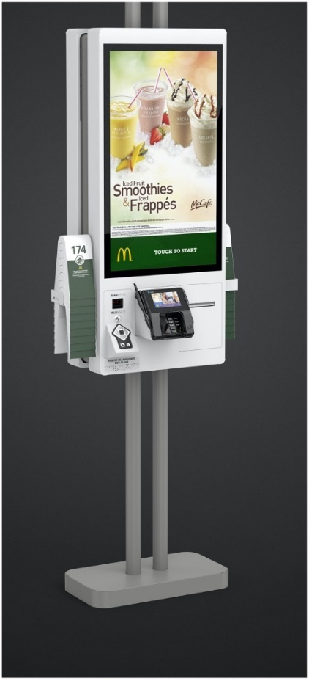**“Initiatives to improve accessibility to products and information for those with disabilities or impairments should be recognized and applauded”, say Storm Interface.**

# Storm Interface, manufacturers of the AudioNav system interface, are working with McDonald’s to accelerate improvements in the accessibility of McDonald’s restaurant kiosks. McDonald’s was recently recognized by the National Federation of the Blind for its achievements in accessibility. Storm are pleased to have had an opportunity to work with McDonald’s delivering an effective audible and tactile customer interface.

# “From the first meeting it was clear that the McDonald’s team had recognized the challenges faced by those who could not see, read or interact with a touchscreen” said Peter Jarvis SEVP at Storm Interface. “We were (and remain) impressed by their willingness to explore and implement new ideas and new technologies. Storm are delighted that the AudioNav device was chosen by McDonald’s to provide the integrated audio connection and tactile interface for navigation of restaurant menu options.”

# “Inclusion is at the core of our values,” said Kelsey Hall, Senior Manager of Global Digital Accessibility at McDonald’s. “Implementing new options for our customers to be able to order independently is vitally important to ensuring the restaurant experience is accessible for everyone.”

# Storm Interface’s AudioNav device is currently being deployed to McDonald’s corporate owned stores and select franchise locations across the US.

Background Information:

About Storm Interface

For more than 35 years Storm Interface have designed and manufactured secure, rugged and reliable keypads, keyboards and interface devices. Storm products are built to withstand rough use and abuse in unattended public-use and industrial applications. Storm Assistive Technology Products are recognized by the Royal National Institute of Blind People under their ‘RNIB Tried and Tested’ program.

[www.storm-interface.com](http://www.storm-interface.com)