MEDIA RELEASE | Contact: Peter Jarvis
 | Storm Interface
 | Phone: +44 (0)1895 456200
 | Email: sales@storm-interface.com
London, England March 2020 | Web: www.storm-interface.com
Storm Interface issues instructions for cleaning its data entry products

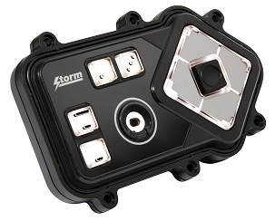
Given the current COVID-19 pandemic, Storm is actively encouraging deployers of its data entry products to perform regular sanitization procedures.
All products in the Storm range are designed to withstand heavy use in unattended public or industrial applications. The metals and polymers used in their construction are impervious to the chemicals frequently found in cleaning products such as alcohol or bleach.
Once installed into the host machine, the devices are sealed to achieve an Ingress Protection (IP) rating of at least IP54 or IP65. Both of these ratings mean that the products can be cleaned using a hand-held spray bottle of cleaning fluid, without causing damage to the product or affecting its performance. This also applies to Storm’s Assistive Technology Products which include an audio jack.
The frequency of cleaning/sanitization will depend on the environment or application in which the device is used. Storm recommend following the procedure explained below:
- Mix a solution of water with mild detergent and anti-bacterial agents, for example products designed for cleaning kitchen surfaces (do not use a solution which contains a limescale remover).
- Use a hand-operated spray bottle to spray solution onto the Storm keypad.
- With a soft-bristled brush (such as a paint brush), work the solution into crevices and recesses to dislodge dirt, residue etc.
- Use a hand-operated spray bottle to rinse the keypad with water.
- A soft cloth lint-free can be used to dry the keypad after rinsing.

Background Information:

About Storm Interface
For more than 30 years Storm Interface have designed and manufactured secure, rugged and reliable keypads, keyboards and interface devices. Storm products are built to withstand rough use and abuse in unattended public-use and industrial applications. Storm Assistive Technology Products are recognized by the Royal National Institute for Blind People under their ‘RNIB Tried and Tested’ program.
www.storm-interface.com

