MEDIA RELEASE | Contact: Peter Jarvis
 | Storm Interface
 | Phone: +44 (0)1895 456200
 | Email: sales@storm-interface.com
London, England February 2018 | Web: www.storm-interface.com
KioWare add support for ADA compliant Storm Assistive Technology Products

KioWare provide the software platforms that define the customer experience in many self-service applications. They are the latest application specialists to add fully integrated platform support for ADA compliance.
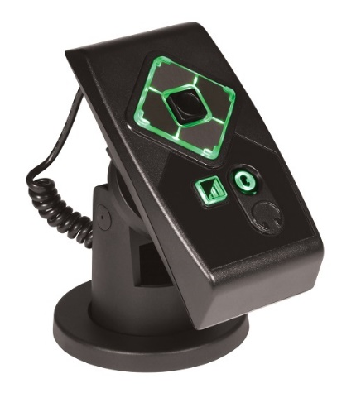
Recognizing that their clients are facing an increasing risk of litigation for any non-compliance with ADA and Section 508 mandates, KioWare have implemented a proactive and customer focused approach to accessibility.
“The first thing on the to-do list was to ensure out-of-the-box compatibility with Storm’s field proven and lab tested system navigation devices”, said James Kruper, President of KioWare. These highly commended assistive technology products provide the tactile and audio interface required to achieve mandated accessibility for kiosk users with sensory impairment, limited dexterity or restricted reach. “The second objective was to achieve an ‘invisible join’ to provide a simple, intuitive and rewarding customer experience. It was essential to make the interaction between Storm’s USB connected tactile devices and the host platform as seamless and as easy as it could be” said Kruper.
Mandated requirements for audible summaries of screen content, navigated by use of a highly responsive tactile interface are often overlooked. KioWare are determined to make ADA compliance easier for system designers and those deploying self-service technology.
“Storm Interface are pleased to confirm KioWare as an approved technology partner”, said Peter Jarvis (Storm’s SEVP). “KioWare have demonstrated a clear commitment to the effective use of Storm products, helping their customers to meet the growing international demand for equality in access to information and services. They are considered a valuable addition the network of expert advisors and suppliers available to Storm customers.”
See Storm’s Assistive Technology Products on the KioWare booth #177, HIMSS18, March 5th – March 9th, Sands Expo Center Las Vegas.

Background Information:

About Storm Interface
For more than 30 years Storm Interface have designed and manufactured secure, rugged and reliable keypads, keyboards and interface devices. Storm products are built to withstand rough use and abuse in unattended public-use and industrial applications. Storm Assistive Technology Products are recognized by the Royal National Institute for Blind People under their ‘RNIB Tried and Tested’ program.
www.storm-interface.com

About KioWare
Originally founded in 1991 as a software and website design company, KioWare began to focus on the development and creation of its kiosk software product line in 2003. As the industry has evolved and expanded, so has the KioWare product. From basic browser lockdown to external device support and remote kiosk management, the product continues to mature.
https://www.kioware.com/

