|  |  |  |
| --- | --- | --- |
| **MEDIA RELEASE** | Contact: Peter Jarvis | |
| Storm Interface | |
| Phone: +44 (0)1895 456200 | |
| Email: sales@storm-interface.com | |
| **London, England. June 2017** | Web: [www.storm-interface.com](http://www.storm-interface.com) | |
| **Storm unveils the latest additions to its range of Assistive Technology Products** | |

Storm's attendance at the recent M-Enabling Summit in Arlington VA, was a unique opportunity to meet with the world’s leading accessibility professionals according to Peter Jarvis, Storm's SEVP.

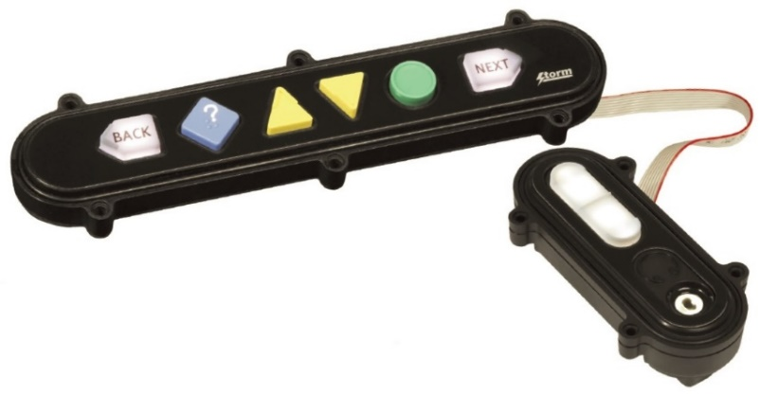‘Specifically we were delighted to receive positive feedback from accessibility professionals who are implementing Storm ATP solutions around the world’ said Jarvis.

As well as its existing ATP products, Storm also unveiled some new additions which will be launched in the coming weeks. These new products offer more mounting options, colors and illumination for Storm's Nav-Bar™. Over 5 new product options are now available.

The M-Enabling Summit has established itself as the leading global conference and showcase dedicated to promoting accessible and assistive technology for senior citizens and users of all abilities. It is an annual meeting place for all who create and contribute accessible ICT products, services and consumer technologies. Bringing together professionals, corporations, service organizations and key thought leaders, the Summit is an all-inclusive conference and showcase featuring innovative technology, mobile applications, connected devices, and services for more than one-billion users worldwide.

Background Information:

Storm Interface is an award winning, UK based, manufacturer of Human Interface Devices.

The Storm range of secured, sealed and toughened data entry devices are field proven and laboratory tested. They are constructed to survive in the most demanding applications and environments. Since 1986, Storm’s design, technology and manufacturing quality have established Storm products as the industry standard for durability and reliability.

[www.storm-interface.com](http://www.storm-interface.com)