|  |  |
| --- | --- |
| **MEDIA RELEASE** | Contact: Peter Jarvis |
| Storm Interface |
| Phone: +44 (0)1895 456200 |
| Email: sales@storm-interface.com |
| **London, England. December 2016** | Web: [www.storm-interface.com](http://www.storm-interface.com) |

**New Middle East Source for Storm-AXS Products**

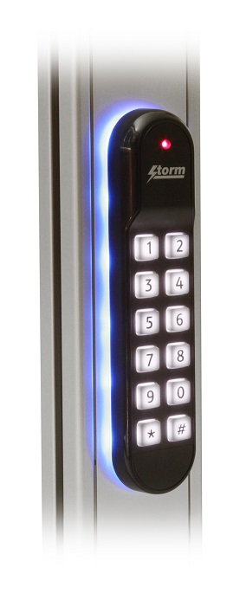**Storm Interface are pleased to announce that the Storm-AXS range of rugged access control products will now be available from Digital Factors UAE.**

*“To coincide with important new additions to the Storm range, we are delighted to introduce a new* ***Storm-in-Stock*** *partner. Digital Factors will serve a growing customer base in the UAE and throughout the Middle Eastern market’ said Peter Jarvis, Storm Interface SEVP.*

The new Storm S60 outdoor rated keypad-readers are ideal for access control applications in contemporary glass or polished stone buildings. An increasing number of these ‘landmark’ buildings can be found in many of the region’s cities. *“We are looking forward to working with the team at Digital Factors to ensure Storm products are featured in many of those ‘signature’ buildings”, said Jarvis.*

Formed with a vision to become a market leader in the secure issuance and physical access arena, Digital Factors are fast becoming one of the largest access control distributors in the Middle East. This growth has been achieved by providing high quality products which exceed their customer’s expectations, whilst maintaining the highest ethical standards.

*“Our harsh climate requires access control equipment that is rugged enough to withstand extreme temperatures, high levels of UV radiation and dry, sandy environments” said Vinod Menon, Operations Manager for Digital Factors.*

*“Constructed in Storm’s ISO9001 accredited UK manufacturing facility, using the highest quality materials, Storm-AXS products are built to last. We are sure that their reliability and durability will be qualities our customers will very much appreciate’ said Vinod Menon.*

The Storm-AXS product range will be demonstrated at Intersec, Jan 22nd to Jan 24th 2017 by Digital Factors at booth number S2-G09, Saeed Hall -2, World Trade Centre, Dubai, U.A.E.

*Ends.*

**Background Information:**

Storm Interface is an award winning, UK based, manufacturer of Human Interface Devices. The Storm range of secured, sealed and toughened data entry devices are field proven and laboratory tested. They are constructed to survive in the most demanding applications and environments. Since 1986, Storm’s design, technology and manufacturing quality have established Storm products as the industry standard for durability and reliability.

[www.storm-interface.com](http://www.storm-interface.com)

Digital Factors is the largest value added distributor for the past 20+ years in the Identity and Access Management space in MENA region & India. We are the distributor for renowned brands like HID, Zebra & IDP.

Some of the key security solutions that DFS has pioneered are: ID and Smart Card Issuance, Physical, Logical and Mobile Access, RFID Tracking, Cashless Payments, Visitor Management and Handheld Security Terminals.

We also add value to our clients by providing in-house custom developed, region specific software products.

[www.dfsme.ae/storm/](http://dfsme.ae/storm/)