|  |  |
| --- | --- |
| **MEDIA RELEASE** | Contact: Peter Jarvis |
| Storm Interface |
| Phone: +44 (0)1895 456200 |
| Email: sales@storm-interface.com |
| **London, England. June 2016** | Web: [www.storm-interface.com](http://www.storm-interface.com) |

**Intermountain Lock & Security Supply to be the first in North America to receive new S60 keypad/reader**

**Storm Interface have confirmed that newly appointed ‘Storm-In-Stock’ partner *Intermountain Lock & Security Supply Inc.* will be the first North American outlet to receive their recently launched S60 keypad/readers.**

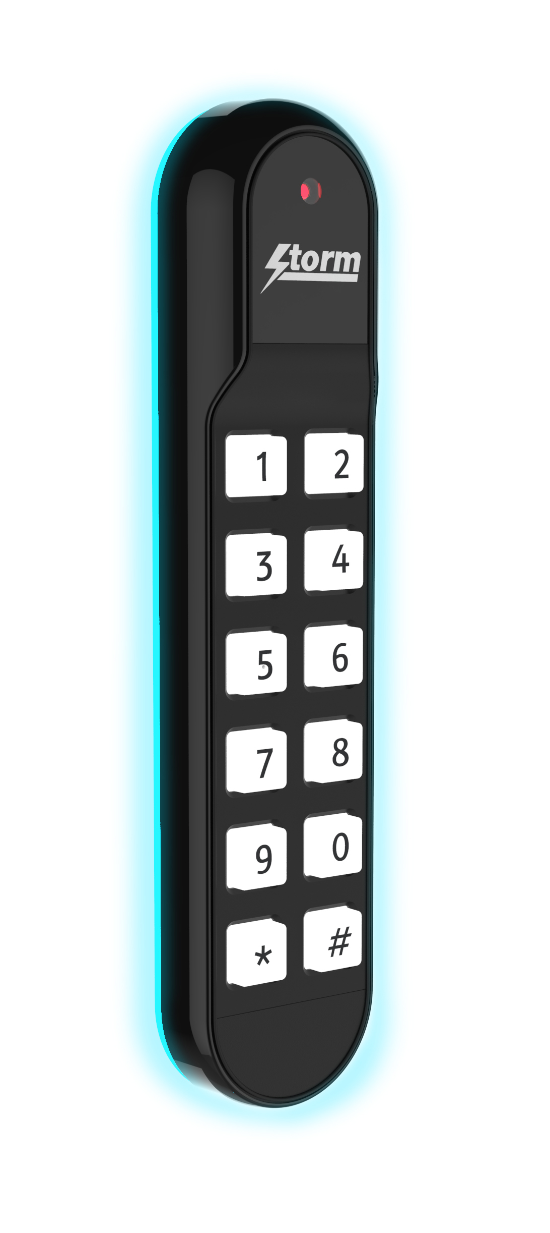‘We are pleased to announce a new partnership with Intermountain Lock & Security Supply’ said Peter Jarvis, SEVP of Storm Interface. ‘The new S60 keypad-contactless reader received a great response from installers at the ISC West trade show, so it’s good to know we have the team at IMLSS to support our North American customers’.

Featuring Genuine HID contactless technology, the new S60 integrated keypad/reader combines innovative technology and contemporary design. When installed, it projects an atmospheric halo of light onto surrounding surfaces, producing an exciting signature effect for landmark buildings. As with all Storm access control products, the S60 is outdoor rated and constructed to survive in extreme environments. It is the latest addition to the acclaimed Storm-AXS range of toughened data entry products.

To learn more about the new S60, or for information about Storm’s outdoor rated access control products visit [www.imlss.com](http://www.imlss.com).

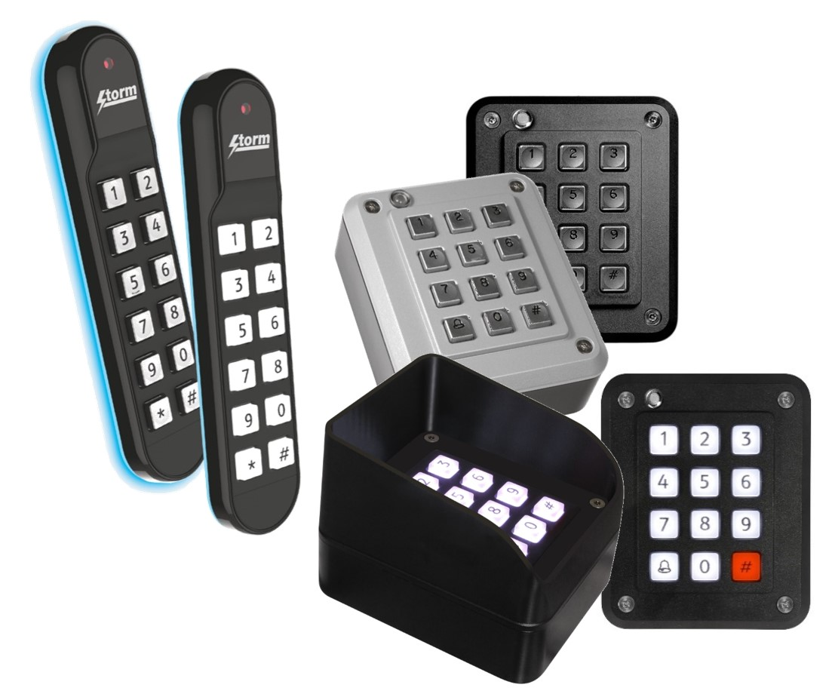

***Ends.***

**Background Information:**

**Storm Interface** is an award winning, UK based, manufacturer of human interface devices.

The Storm range of secured, sealed and toughened data entry devices are field proven and laboratory tested. They are constructed to survive in the most demanding applications and environments. Since 1986, Storm’s design, technology and manufacturing quality have established Storm products as the industry standard for durability and reliability.

[www.storm-interface.com](http://www.storm-interface.com)

**Intermountain Lock & Security Supply**

Founded in 1966, Intermountain Lock & Security Supply is a wholesale distributor offering products from all major manufacturers in the Security and Locksmithing industry. Expertly trained staff coupled with excellent customer service is just one of the reasons IMLSS is one of the leading wholesale distributors in the Western United States.

www.imlss.com