|  |  |
| --- | --- |
| **MEDIA RELEASE** | Contact: Peter Jarvis |
| Storm Interface |
| Phone: +44 (0)1895 456200 |
| Email: sales@storm-interface.com |
| **London, England. December 2015** | Web: [www.storm-interface.com](http://www.storm-interface.com) |

**Breaking News:**

**New Storm-AXS Keypads available from industry leaders.**

During 2015 Storm introduced the first in a new generation of toughened access control keypads featuring HID® iCLASS® and SEOS® contactless technology. These products are now available from the world’s leading suppliers of Access Control products. As Storm prepare to announce important new additions to their AXS range of products, they took time to recognize the important role played by their distribution partners. Speaking from their UK headquarters Peter Jarvis (Senior Executive VP) said “Excellence in product design and a reputation for product durability is an absolute necessity. However in a global market it is also essential to have established distribution channels to ensure product supply and world class product support. We knew that the new S40 and S60 products were a major step forward in product technology, but access to those sectors of the market that demand premium quality and performance was absolutely essential**”. ADI Global, Norbain SD Ltd, Kestronics Ltd and SmartR Distribution** have an established presence and proven reputations in international markets. They also have a clear understanding of what their customers demand and the unique advantages offered by these new Storm products. “They are highly valued Storm-in-Stock partners”, said Jarvis.

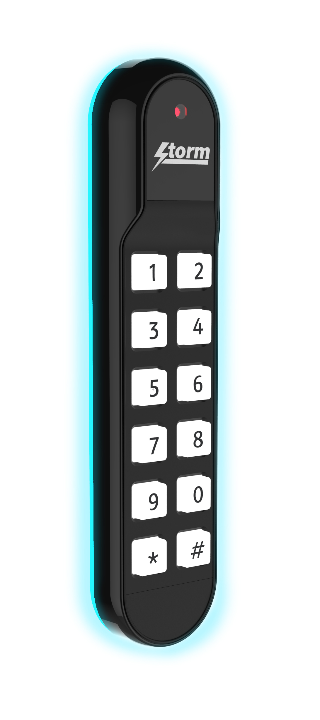**NEW for 2016 is the S60 range of mullion format keypad readers.**

**Increasing use of architectural glass and polished stone wall finishes create unique challenges for installers of access control systems. Keypads and readers must be easily installed (or pre-installed) within the width of a door frame or mullion**.  They must also convey an uncompromised commitment to luxury, quality and style. To meet this demand for both innovative technology and contemporary design, Storm have created an integrated keypad/reader that uniquely exploits the use of light and form.

**When installed, the new S60 keypad/reader projects an atmospheric halo of light onto surrounding surfaces, producing an exciting signature effect for landmark buildings**. This company’s mission is to prove that durable, ultra-reliable, interface devices can also make a statement in contemporary product design.

Do not miss the first showing of the new Storm-AXS S60 keypad at Intersec 2016 in Dubai. Storm-AXS will be demonstrating these exciting new products in Hall S1, stand number H29

Dubai is a location that features many of the world’s contemporary landmark buildings. Intersec 2016 provides a unique opportunity to establish and develop relationships with leading architects, designers and building management companies. For an innovative British company, the UAE represents a market sector that demands premium quality and excellence in design.

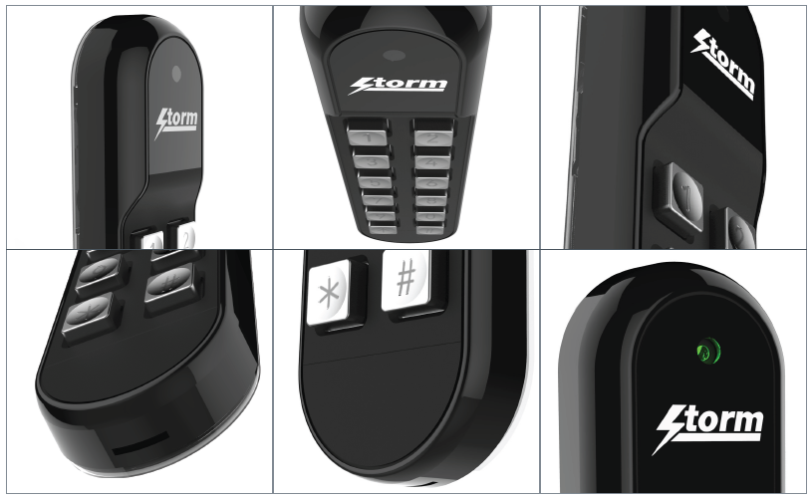

***Ends.***

**Background Information:**

Storm Interface is an award winning, UK based, manufacturer of human interface devices.

The Storm range of secured, sealed and toughened data entry devices are field proven and laboratory tested. They are constructed to survive in the most demanding applications and environments. Since 1986, Storm’s design, technology and manufacturing quality have established Storm products as the industry standard for durability and reliability.

[www.storm-interface.com](http://www.storm-interface.com)