|  |  |  |
| --- | --- | --- |
| **MEDIA RELEASE** | Contact: Peter Jarvis | |
| Storm Interface | |
| Phone: +44 (0)1895 456200 | |
| Email: sales@storm-interface.com | |
| **London, England. November 2015** | Web: [www.storm-interface.com](http://www.storm-interface.com) | |
| **While gamers push pedal to the metal, Storm’s display is music to their ears** | |

As the company that brought us ‘Sonic the Hedgehog’ and a major force in the gaming industry for decades, SEGA know how to design and build arcade games that thrill and excite gamers. They also understand just how demanding the arcade environment can be.

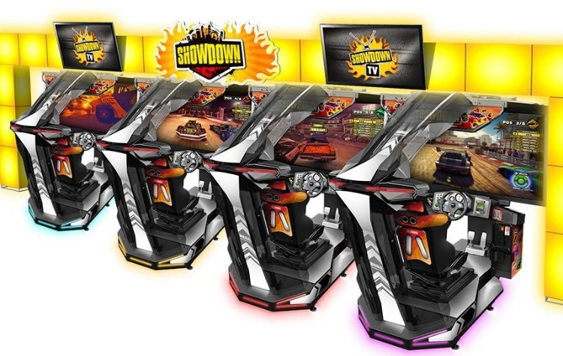So when it came to choosing the hardware for the radio in their ground breaking new arcade racing game ‘Showdown Special Attraction’ they knew they needed a toughened display capable of withstanding hard use in a demanding environment.

The display they chose was the 5100 Series USB Display from Storm Interface. Offered in eight different configurations/specifications, Storm 5100 Series Displays are rated for use in either industrial or extreme environments and provide a ‘ready to use’ display solution for a wide range of indoor or outdoor applications.

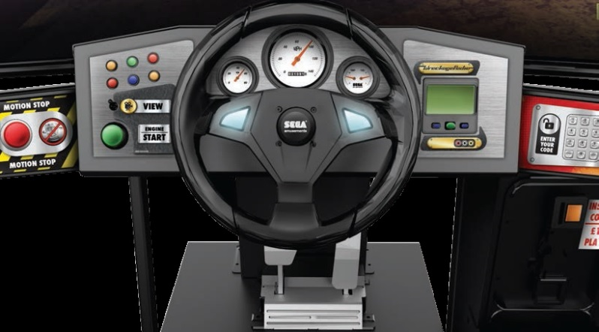For the Showdown project, SEGA partnered with racing specialists Codemasters to deliver a combination of ground-breaking new technology and innovative video game cabinet design. The brief was to take the arcade racing experience to a whole new level so just like in a real car, gamers can listen to music while they race. The Storm 5100 Display is positioned on the dashboard and allows them to view & select music tracks from ‘Wreckage Radio’.

Patrick Michael, SEGA Europe’s Head of Local Research & Development said ‘We wanted to bring gamers the ultimate in realism and Showdown has a fully working instrument panel, pivot motion technology and stunning graphics. But arcades are very demanding environments’ said Michael ‘So we needed a display which looked good, but could also stand up to public use and abuse. The 5100 USB display from Storm fit the bill perfectly’.

For more information on the 5100 Series USB Display, please visit [www.storm-interface.com/displays/5100-series.html](http://www.storm-interface.com/displays/5100-series.html)

Ends

**Background Information:**

**Storm Interface** is an award winning, UK based, manufacturer of human interface devices. The Storm range of secured, sealed and toughened data entry devices are laboratory tested and field proven. They are constructed to survive in the most demanding applications and environments. Since 1986, Storm’s design, technology and manufacturing quality have established Storm products as the industry standard for durability and reliability.

For more information, visit [www.storm-interface.com](http://www.storm-interface.com)

**SEGA** is one of the leading interactive entertainment companies, cultivating creative talent worldwide with offices in America, Japan and its European HQ in London. SEGA's much loved blue hedgehog mascot is a true global brand crossing over from video games into toys, stationary, apparel and much more.

For more information, visit [www.sega.com](http://www.sega.com)