|  |  |
| --- | --- |
| **MEDIA RELEASE** | Contact: Peter Jarvis |
| Storm Interface |
| Phone: +44 (0)1895 456200 |
| Email: sales@storm-interface.com |
| **London, England. July 2015** | Web: [www.storm-interface.com](http://www.storm-interface.com) |
| Installation Engineers Select Mouser for System Components | |

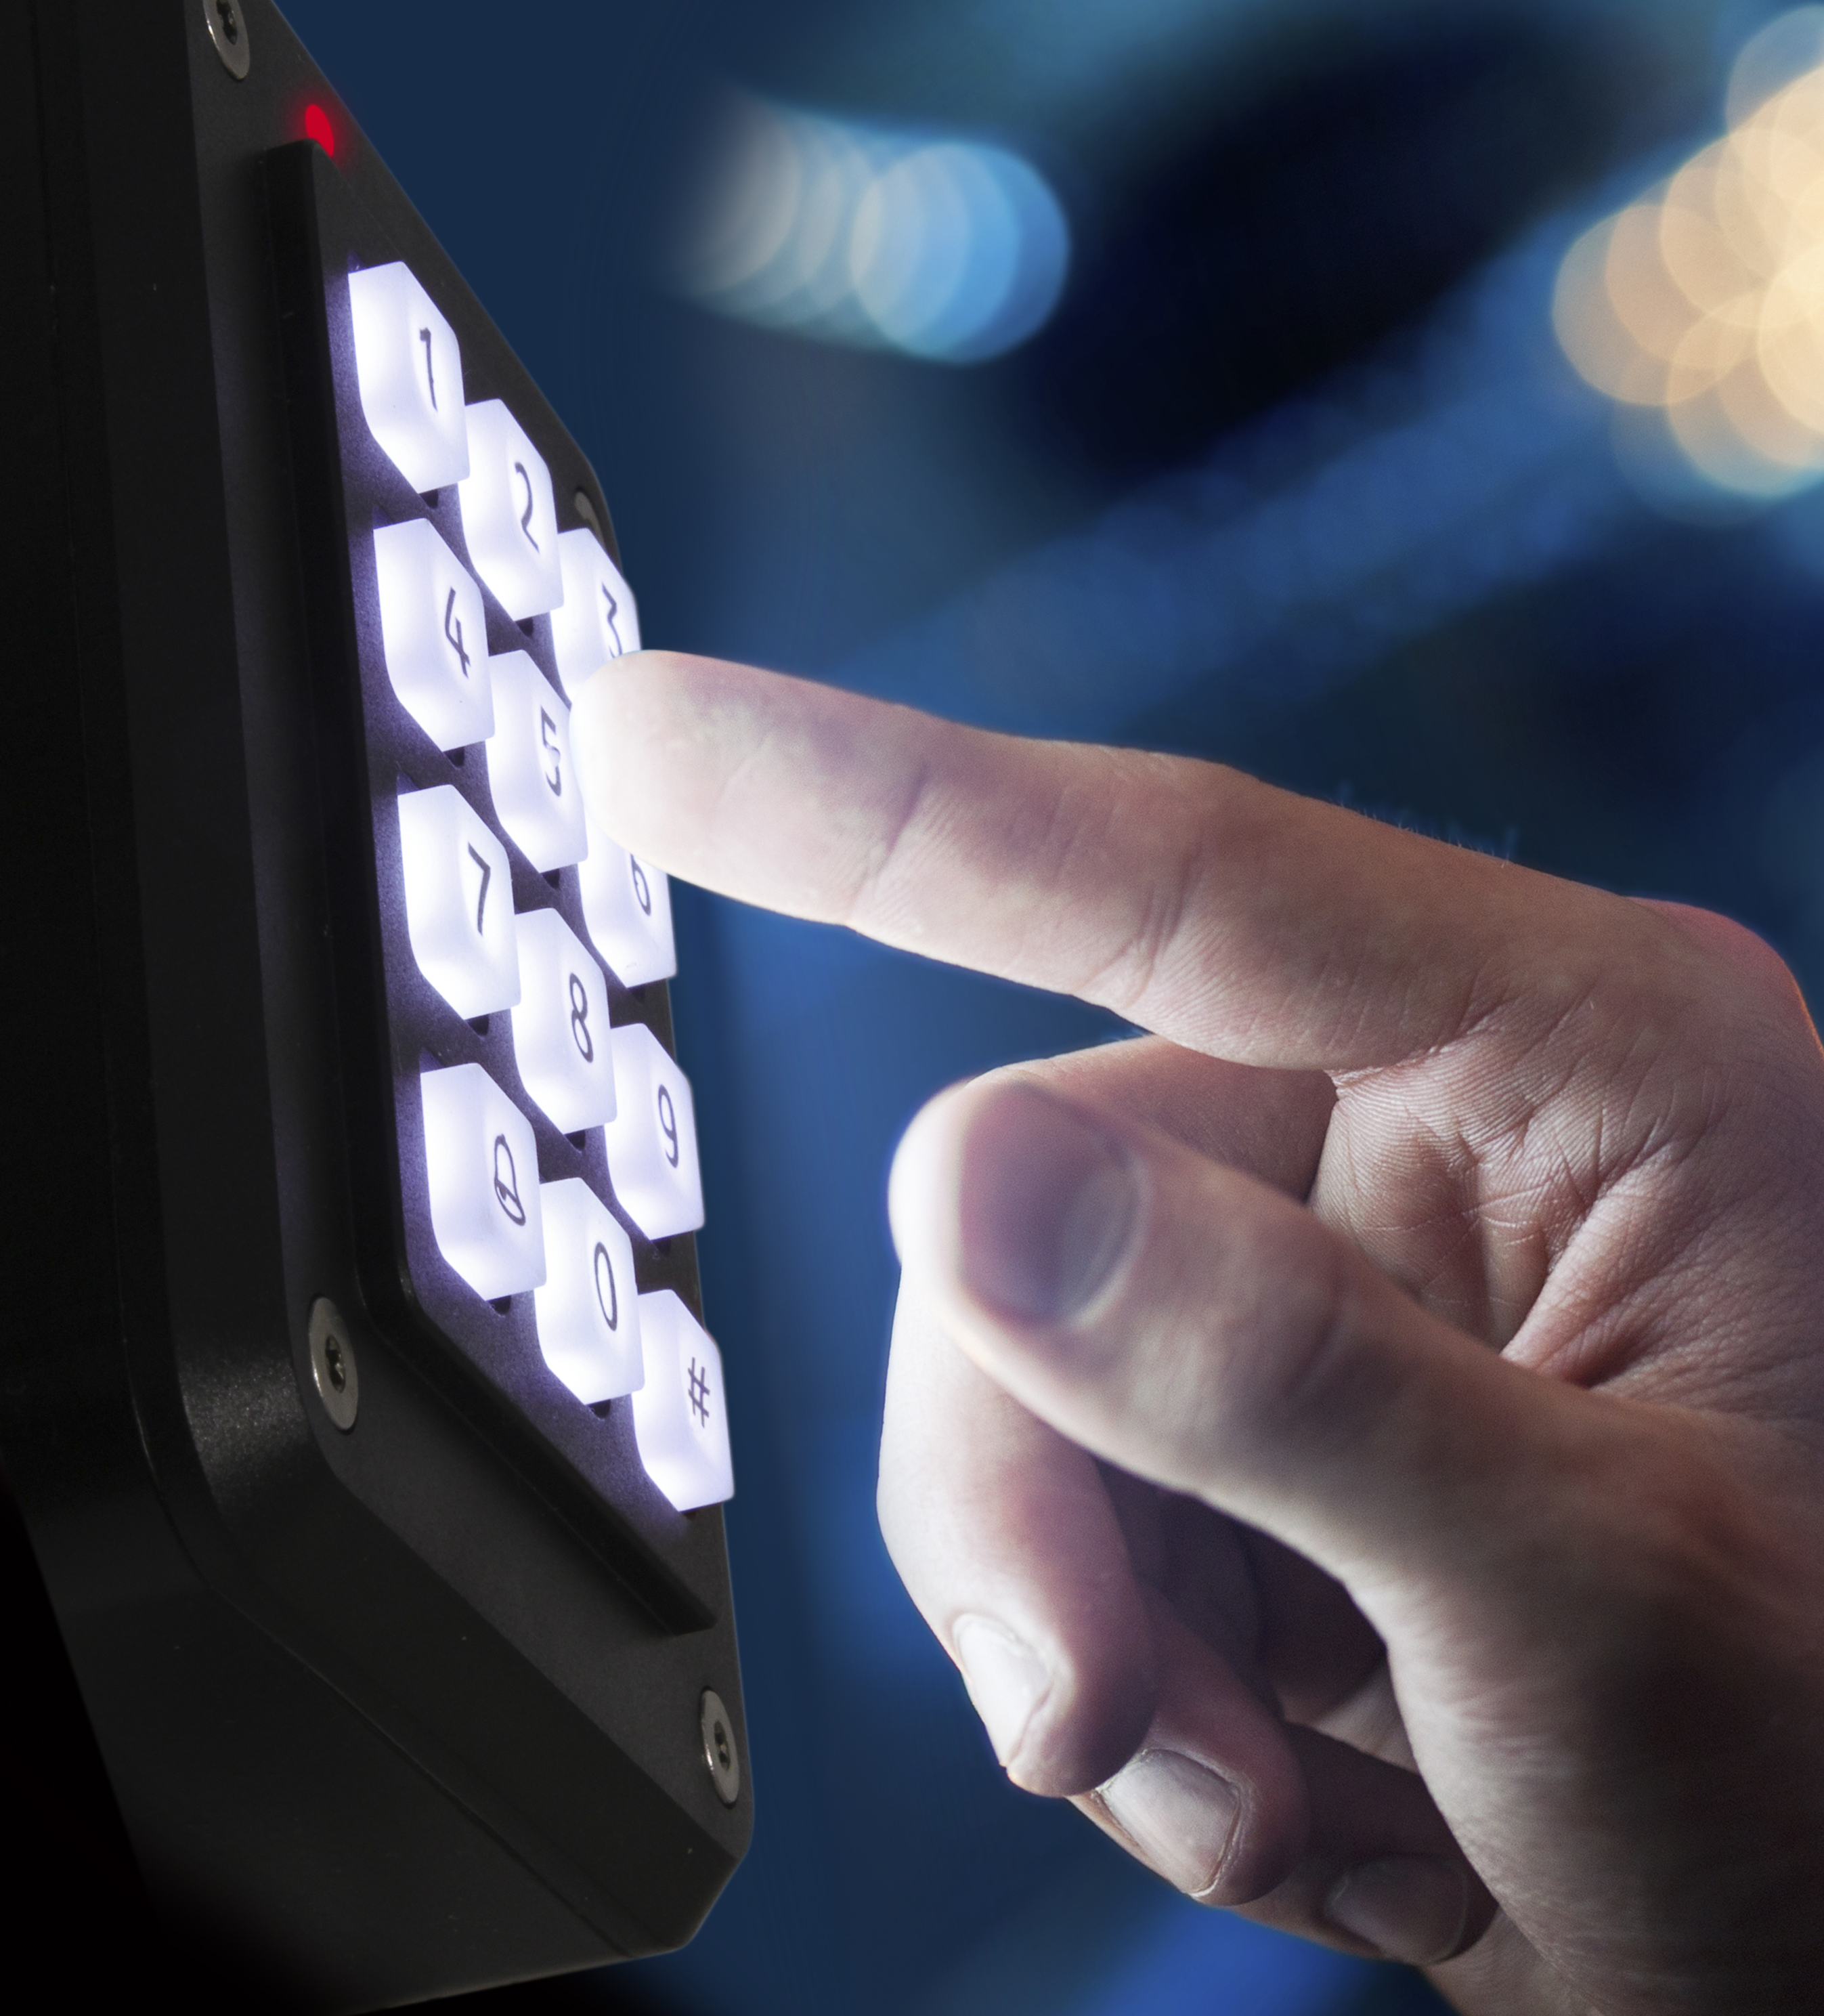**Professional installers of Access Control equipment prefer Mouser Electronics**. That was the clear message received at ISC West in Las Vegas as Storm-Interface introduced a new generation of their Storm-AXS keypads.

These toughened, accessible, weather-resistant keypads have long been the first choice of European installation engineers who voted these UK manufactured products as the Number 1 “fit and forget” access control device. Not surprisingly security equipment installers in North America began to demand a supply source for these acclaimed products. Storm were pleased to learn that many already had accounts with global authorized distributor Mouser Electronics.

“We wrongly assumed that these security professionals would buy system components only from specialist trade suppliers”, says Nicky Shaw, Storms’ North American Distribution Manager. “However we quickly learned that installers would prefer to buy from an internationally recognized, leading authorized, stock-holding distributor like Mouser; who could offer same-day dispatch directly to the installation site. Highly evolved delivery logistics were, for many, the most important requirement. Many told us that they had existing accounts with Mouser as their chosen supplier of cables, connectors and fixings. For them it made perfect sense to order major system components from the same source.”

“We were proud to have Mouser as one of our sponsors at ISC West and delighted to see how many of our customers already had a strong business relationship with Mouser. Storm are pleased to welcome Mouser Electronics as a Storm-in Stock partner”.

***Ends.***

**Background Information:**

Storm Interface is an award winning, UK based, manufacturer of human interface devices. The Storm range of secured, sealed and toughened data entry devices are field proven and laboratory tested. They are constructed to survive in the most demanding applications and environments. Since 1986, Storm’s design, technology and manufacturing quality have established Storm products as the industry standard for durability and reliability.

For more information, visit [www.storm-interface.com](http://www.storm-interface.com/)



Mouser Electronics, a subsidiary of TTI, Inc., is part of Warren Buffett's Berkshire Hathaway family of companies. Mouser is an award-winning authorized semiconductor and electronic component distributor, focused on the rapid introduction of new products and technologies to electronic design engineers and buyers. Mouser.com features more than 4 million products online from more than 500 manufacturers. Mouser publishes multiple catalogues every year providing designers with up-to-date data on the components now available for the next generation of electronic devices. Mouser ships globally to over 500,000 customers in 170 countries from its 492,000 sq. ft. state-of-the-art facility south of Dallas, Texas.

For more information, visit [www.mouser.com/](http://www.mouser.com/).