|  |  |  |
| --- | --- | --- |
| **MEDIA RELEASE** | Contact: Peter Jarvis | |
| Storm Interface | |
| Phone: +44 (0)1895 456200 | |
| Email: sales@storm-interface.com | |
| **London, England. July 2015** | Web: [www.storm-interface.com](http://www.storm-interface.com) | |
| **Electrostatic Discharge – The Stealthy System Killer** | |

It’s a hot, dry morning and Kate is smartly dressed ready for her first client meeting. Stepping off the crowded train she tries to avoid physical contact with the grubby metro infrastructure and the passengers jostling up towards the sunlit sidewalk. With her briefcase in one hand and security pass in the other, she approaches Tower Point.

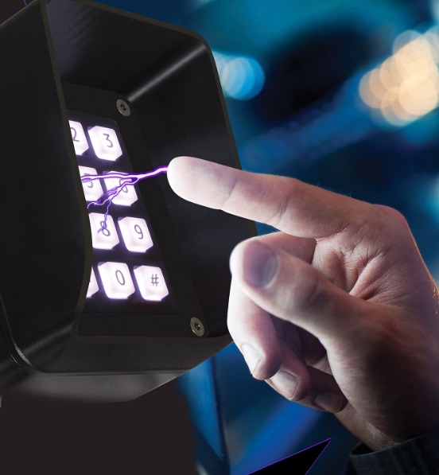The automated glass doors slide open. As she enters the lobby her heels click across the highly polished vinyl floor. She moves purposefully towards the brightly illuminated keypad that will read her pass card and check her numeric code. As she reaches to tap her card Kate is unprepared for the destructive force that will, in just a few milliseconds, course through her body. A force that will cause extensive and immediate damage to the complex security system that ensures her safety.

During Kate’s journey to the office she accumulated an electrostatic charge of almost 15,000 Volts on the surface of her clothes and body. This was mostly generated by friction caused by movement. In the dry atmosphere this accumulated charge was slow to dissipate. The first opportunity for this high voltage potential difference to achieve equilibrium occurred as a spark jumped from her hand to the grounded keypad.

Many of us have experienced a similar **static shock**. Usually we complain that it is the object we touched that gave us the shock, when in reality it was us that delivered the shock to the object.

In the story above, Kate would have delivered about 12,000 volts to the access security system.

During that same morning the system would have received several similar shocks. Those attacks would probably leave no visible evidence and the damage caused would eventually manifest itself as either faulty hardware or software corruption. In many cases the fault may occur intermittently or at some later time.

It is estimated that **damage caused by electrostatic discharge** accounts for more than **60%** of ‘in service’ system faults. A**ccess control systems are particularly vulnerable** as they often present the first grounded point of contact. In response to this problem, the engineers at Storm Interface have designed an access control keypad which has one of the highest ESD ratings in the industry. **The new AXS S40i access control keypad from Storm Interface is ESD rated & certified to 15kV,** a reassuringly high number which **exceeds most public sector requirements.**

Featuring genuine HID® iCLASS SE®, Seos®, contactless technology, this illuminated access control keypad offers enhanced security by dual authentication. Weather and vandal resistant and built to survive in extreme conditions.

**Background Information:**

**Storm Interface** is an award winning, UK based, manufacturer of human interface devices. The Storm range of secured, sealed and toughened data entry devices are laboratory tested and field proven. They are constructed to survive in the most demanding applications and environments. Since 1986, Storm’s design, technology and manufacturing quality have established Storm products as the industry standard for durability and reliability.

For more information, visit [www.storm-interface.com](http://www.storm-interface.com)

**Ends.**