|  |  |  |
| --- | --- | --- |
| **MEDIA RELEASE** | Contact: Peter Jarvis | |
| Storm Interface | |
| Phone: +44 (0)1895 456200 | |
| Email: sales@storm-interface.com | |
| **London, England. February 2015** | Web: [www.storm-interface.com](http://www.storm-interface.com) | |
| **STORM choose HID Global’s iCLASS SE**® **platform to drive new generation of AXS products** | |

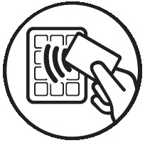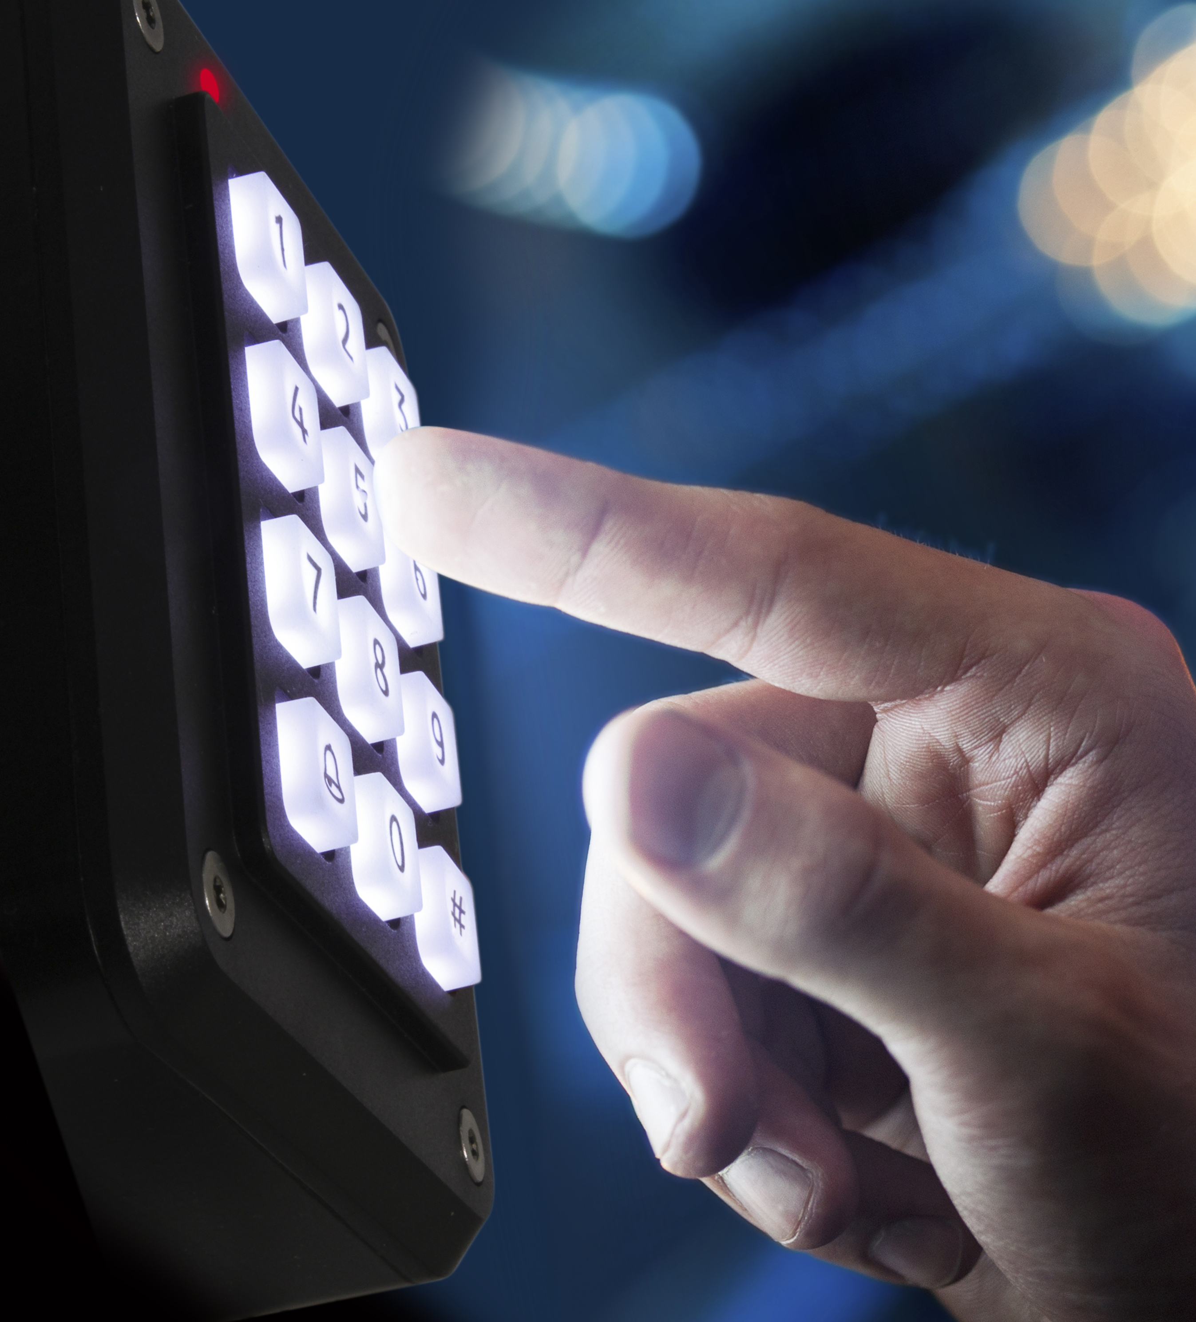**As Storm prepare to announce their new product line up for 2015, news emerges that they will introduce a new generation of keypads with integrated genuine HID**® **contactless technology. These keypads will offer enhanced security with dual authentication. A combination of PIN entry and presentation of a contactless card requires both *knowledge* and *possession* to achieve authorized access.**

**Designated as the AXS S40 and S40i, first customer shipments will commence in April of this year.**

Developed to meet new accessibility standards, the keypads feature bold keytop characters permanently marked onto full size keys. Excellent tactile response and tactile delineation make these keypads ideal for use by those with sensory or mobility impairment. Optional keytop illumination ensures they are suitable for use in dark or partially lit locations. Impact resistant and sealed against the ingress of water and dust, these keypads are rated for continuous use in both outdoor and indoor locations.

Pairing the legendary durability of Storm keypads with HID Global’s contactless technology creates a new gold standard for an access control interface. **“Storms adoption of Genuine HID technology provides customers with additional choice and options for improved accessibility” said HID’s Thierry Roz (Director, EMEA Embedded Business Development). “Access for those with impaired vision or restricted mobility is seen as much more than a compliance issue. It is a basic human consideration.”**

Storm’s AXS StrikeMaster, StrikeMaster ES and the AXS S40 keypads can be seen at:

***ISC West, Las Vegas, April 15th - 17th 2015, Booth 31096***

***IFSEC, London, 16th - 18th June, Booth C1850***

***Ends.***

**Background Information:**

Storm Interface is an award winning, UK based, manufacturer of human interface devices.

The Storm range of secured, sealed and toughened data entry devices are field proven and laboratory tested. They are constructed to survive in the most demanding applications and environments. Since 1986, Storm’s design, technology and manufacturing quality have established Storm products as the industry standard for durability and reliability.

[www.storm-interface.com](http://www.storm-interface.com)

HID Global is the trusted source for innovative products, services, solutions, and know-how related to the creation, management, and use of secure identities for millions of customers around the world. The company’s served markets include physical and logical access control, including strong authentication and credential management; card printing and personalization; visitor management systems; highly secure government and citizen ID; and identification RFID technologies used in animal ID and industry and logistics applications. The company’s primary brands include ActivID®, EasyLobby®, FARGO®, IdenTrust®, LaserCard®, Lumidigm®, and HID®. Headquartered in Austin, Texas, HID Global has over 2,200 employees worldwide and operates international offices that support more than 100 countries. HID Global® is an ASSA ABLOY Group brand. For more information, visit http://www.hidglobal.com.