|  |  |  |
| --- | --- | --- |
| **MEDIA RELEASE** | Contact: Peter Jarvis | |
| Storm Interface | |
| Phone: +44 (0)1895 456200 | |
| Email: sales@storm-interface.com | |
| **London, England. March 2015** | Web: [www.storm-interface.com](http://www.storm-interface.com) | |
| **Storm Interface confirm Digi-Key as a global source for access control products** | |

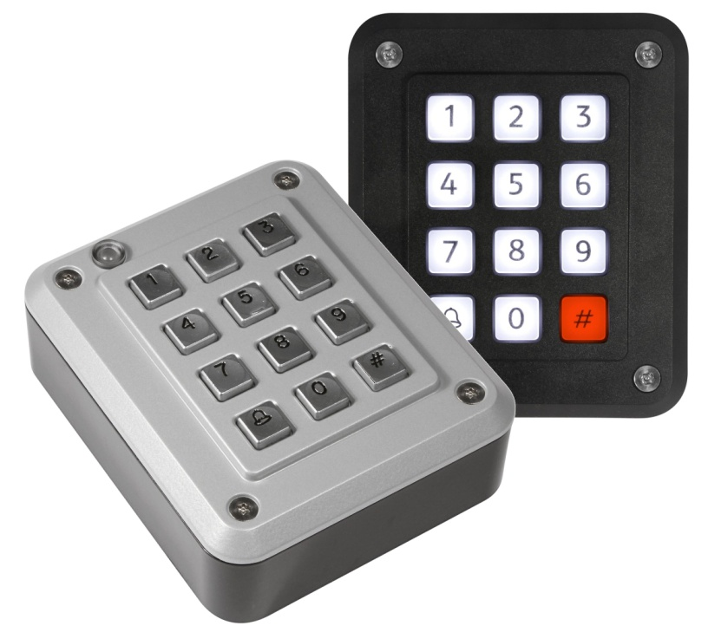

**Storm Interface are expected to reveal some exciting new additions to their AXS product range at ISC West in April and also at IFSEC International in June.**

**“A continuous programme of product development and the addition of new supply channels will further strengthen the Storm AXS brand”** says Storm’s CEO Peter Ward. **“We are therefore pleased to announce a new global distribution agreement with Digi-Key Corporation”**. Digi-Key are an experienced and valued ‘Storm-in-Stock’ partner. They are already well recognised as a primary source for Storm’s industrial products. “**We are delighted that Digi-Key have marked their entry into the access control market with a commitment to the Storm AXS brand**” said Ward.

Digi-Key’s association with the Storm brand began back in 1999, a relationship that quickly positioned Digi-Key as a leading global source for these UK manufactured products. Storm will be exhibiting at several high profile tradeshows during 2015, signalling the start of a joint marketing initiative to promote Digi-Key and Storm-AXS as the professional grade, UL294 certified access control solution.

Ends.

**Background Information:**

Storm Interface is an award winning, UK based, manufacturer of Human Interface Devices.

The Storm range of secured, sealed and toughened data entry devices are field proven and laboratory tested. They are constructed to survive in the most demanding applications and environments. Since 1986, Storm’s design, technology and manufacturing quality have established Storm products as the industry standard for durability and reliability.

[www.storm-interface.com](http://www.storm-interface.com)

Digi-Key Corporation is one of the fastest growing distributors of electronic components in the world.

Since its foundation in 1972, Digi-Key has been committed to offering the broadest selection of in-stock electronic components, as well as providing the best service possible to its customers, aiding engineers through the entire design process, from Prototype to Production®. This has led the company to be highly ranked year after year in industry surveys, in North America as well as Europe and Asia, in categories covering such facets of business as availability of product, speed of service, responsiveness to problems, and more.

[www.digikey.com](http://www.digikey.com)