|  |  |  |
| --- | --- | --- |
| **MEDIA RELEASE** | Contact: Peter Jarvis | |
| Storm Interface | |
| Phone: +44 (0)1895 456200 | |
| Email: sales@storm-interface.com | |
| **London, England. April 2015** | Web: [www.storm-interface.com](http://www.storm-interface.com) | |
| **British manufacturer to announce global sources initiative at IFSEC in London** | |

**As Storm Interface prepare to launch exciting new additions to their AXS access control systems, they are simultaneously opening new channels to an expanding global market.**

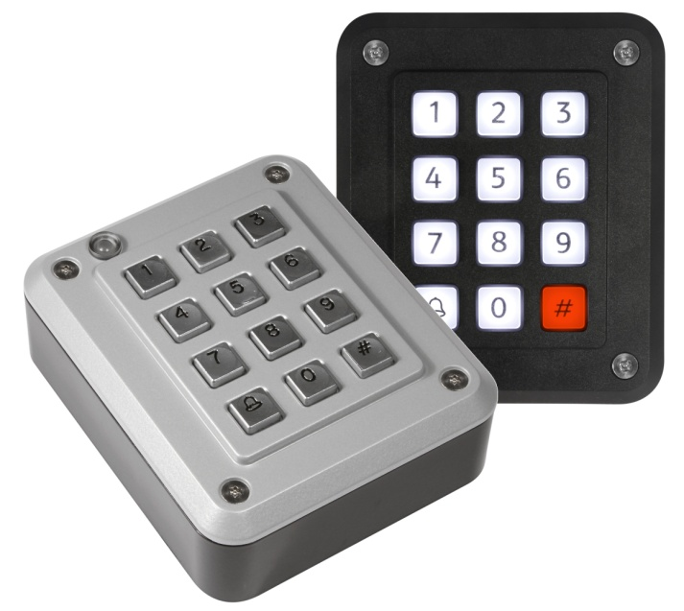Storm consider that availability from stock and world class customer support are essential requirements for the successful launch of their new StrikeMaster ES Access Control system. As a small British company with a big reputation it was clear that Storm would need to ensure robust supply channels to their target markets. To extend their international reach they decided to work with some of their most experienced distribution partners. **“Partners with proven capability to encompass and service our target sectors around the world”, says Peter Jarvis (Senior Exec VP).**

Storm’s choice of Launch Partners may surprise some, but not those who understand the fundamental changes occurring within the global distribution sector. **“We needed both broad-line and trade-specialist distributors”, explains Jarvis. “Our customers expect multi-channel supply mechanisms from recognised sources. They demand partners who are able to ship products from stock as and when demand occurs. They prefer to deal with suppliers with whom they have account facilities and confidence in the levels of service and support they provide. But most importantly, they need suppliers with logistics and global resources to deliver on-spec and on-time”.**  For these reasons Storm looked very closely at their existing ‘Storm-In-Stock’ partners to identify those with a truly global capability.

**As part of the Electrocomponents Group, Allied Electronics and RS Components will be Official Launch Partners for the new StrikeMaster ES product range.** With distribution centres in the world’s major industrial and commercial sectors Electro Components Group will ensure rapid product supply allied with local presence and support. All this backed by an industry leading product warranty programme.

**Ends.**

**Background Information:**

Storm Interface is an award winning, UK based, manufacturer of human interface devices.

The Storm range of secured, sealed and toughened data entry devices are field proven and laboratory tested. They are constructed to survive in the most demanding applications and environments. Since 1986, Storm’s design, technology and manufacturing quality have established Storm products as the industry standard for durability and reliability.

[www.storm-interface.com](http://www.storm-interface.com)

Electrocomponents plc are the world’s largest distributor of electronics and maintenance products. They distribute 500,000 electronics and maintenance products from around 2,500 leading suppliers under the trading brands of RS Components and Allied Electronics.

Their product range extends from semiconductors and optoelectronics to power tools and protective clothing.

From 17 warehouses they ship 46,000 parcels on the same day orders are received. Serving 1.6 million customers across the world, they have corporate operations in 32 countries and distributors in a further 37 markets.

[www.electrocomponents.com/](http://www.electrocomponents.com/)